**LEBANESE AMERICAN UNIVERSITY**

**USAID – HIGHER EDUCATION SCHOLARSHIP PROGRAM**

**HES - Volunteering Program Verification Form**

This form is to be used to document volunteering hours. If a student volunteers for multiple organizations, a separate form must be used for each organization. **This form must be turned in by the 28th of each month, the latest.**

I certify that the scholar Hamza dayekh completed a total of 5 hours of service at Life Sculptor.

The hours were completed hours as per the below:

Hours # 1 (date) _30/09 – 5/10_ (initials of supervisor) __A.K.___

Hours # 1 (date) _7/10 – 11/10_ (initials of supervisor) __A.K.___

Hours # 3 date) _14/10 – 18/10 (initials of supervisor) __A.K.___

Hours # 0 date) _21/10 -25/10 (initials of supervisor) __A.K.___

Brief description of the activities the scholar performed or participated in:

I created a message, prepared a certificate, and organized the internship papers.

Written feedback about the scholar’s performance:

Hamza Dayekh demonstrated commendable initiative and organizational skills by creating a message, preparing a certificate, and efficiently organizing the internship papers. His ability to handle multiple tasks simultaneously showcases his strong time management skills and attention to detail. Hamza’s proactive approach in completing these assignments is impressive and contributes positively to the team's overall productivity.

Please rate the overall performance of the scholar at your organization:

|  |  |  |  |
| --- | --- | --- | --- |
|  | Mastery (5) | Proficient (3) | Emerging (1) |
| **Problem solver** | X |  |  |
| **Engaged & Committed** | X |  |  |
| **Open-minded & multicultural** | X |  |  |

Signature

& stamp

__________________________

_

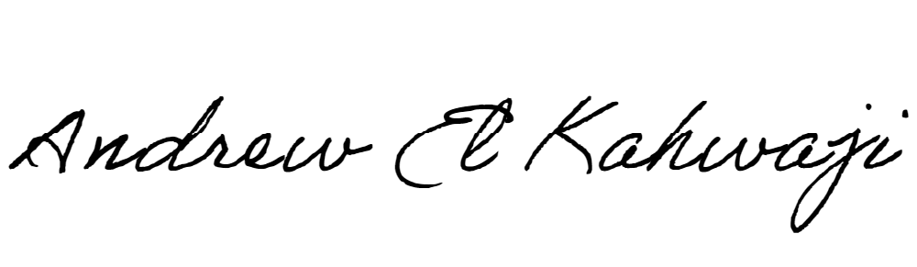

Printed Name _Andrew El Kahwaji_

Date __26/10/2024___

Email __andrew.lifesculptor.coo@gmail.com __

Phone __+961 71 914 378__

**LEBANESE AMERICAN UNIVERSITY**

**USAID – HIGHER EDUCATION SCHOLARSHIP PROGRAM**

